Gardening in Containers: Small Spaces, Big Results

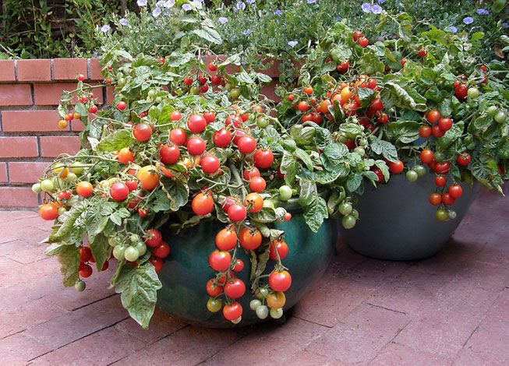

Wednesday, June 5, 2024
12:00 noon – 12:45 p.m.

We don’t all have the time, space, good soil, or energy to plant and maintain the sprawling perennial or vegetable garden of our dreams. But we can grow fruits, vegetables, herbs, and annuals in container gardens. Decorate your patio, balcony, porch, windowsill, or other small space with containers and enjoy the results of your labor in bouquets and on the dinner table. Learn what to consider when choosing your container and plants, what soil and fertilizer choices make the most sense, how to care for and maintain your containers over the growing season, and how to overwinter delicate plants.
Presenter: Christine Saplan, Master Gardener

To register, go to: https://meetny.webex.com/weblink/register/ra813f536b62feba7711df8ada0a75556

