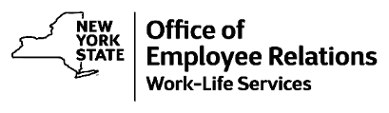

WellNYS Everyday

**Finding Success with Personal Finances**

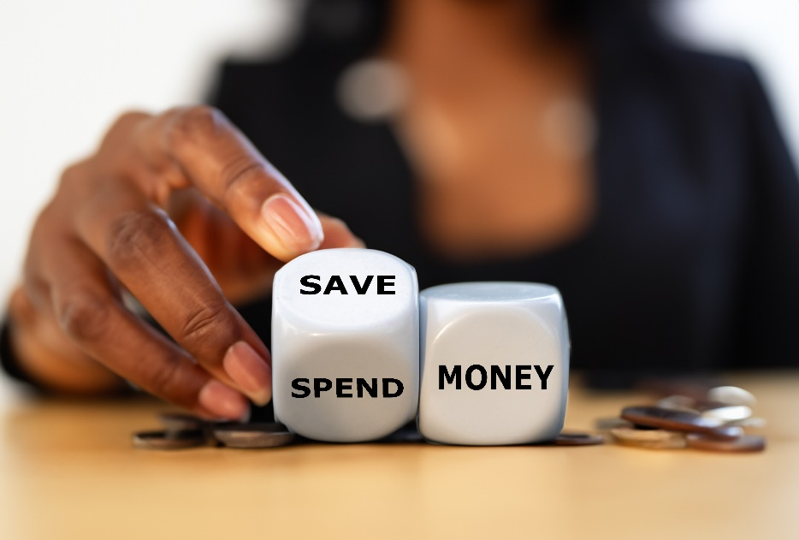

**Monday, March 31, 2025**

**12:00 noon – 12:25 p.m.**

Being successful with personal finances doesn’t just happen. It takes doing the work and making conscious decisions every day on how to spend and save money. Every week in April, the WellNYS Weekly Challenges will provide actions and goals to be successful with personal finances. Are you ready to start making progress with finances? For more information join this 25-minute webinar.



[Register](https://meetny-gov.webex.com/weblink/register/r2ef9891006ed45de979fe8070e96c0b9)

If you are unable to attend live, this webinar will be recorded and put on the WellNYS Everyday website.

WellNYS Everyday is a wellness initiative dedicated to educating, engaging, and empowering New York State employees to engage in healthy behaviors.