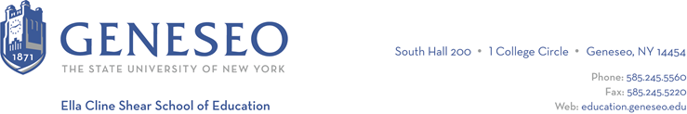

Hello,

Below is the weekly newsletter from the Coordinator of Advisement, Certification, and Communication. You’ll find upcoming School of Education events, along with professional development and employment opportunities shared with the SOE Dean’s Office (we don’t vet any of these opportunities, we just post what’s shared with us). If you have any questions or would like to get in touch with the people or organizations offering opportunities, please don’t hesitate to ask. I’m happy to forward any information I have.

Faculty Activities:
Dr. Peter Kalenda was a panelist on a webinar on Wednesday, July 24th titled Social Science Research and Evaluation: Equitable Approaches to DEAI Efforts. The panel was hosted by the Association of Zoos and Aquariums (AZA).

Professional Development Opportunities:
The British Dyslexia Association’s Dyslexia Style Guide provides useful information for those looking to make their written materials more accessible.

The NYS Math and Science Teaching Incentive Program is a scholarship for full-time undergraduate or graduate students in approved programs pursuing careers as math and science teachers in secondary education (grades 7-12).

Employment Opportunities:
Dansville High School is searching for a 9th grade English teacher. Please reach out to Dave Moodie, the High School Principal, at MoodieD@dansvillecsd.org with any questions.

Empire State Service Corps: If you have a desire to do good and make a difference, you can get hands-on experience and serve your community through paid internships in civic and public service with the Empire State Service Corps. Corps members are expected to work 300 hours over the academic year (an average of 10 hours per week) and will be paid $16 an hour.

Assignments could include tutoring in high-need K-12 schools, taking climate action working with leading State agencies, disaster relief and mitigation after severe weather events, working as a student success coach with an organization, and support for regional food banks and SNAP outreach to address food insecurity. These internships will allow you to engage in meaningful work that can provide lifelong skills as well as service to your community. For more information please review the website or email the Career Design Center at careers@geneseo.edu. Apply now to be a Corps Member!

KIPP Albany Community Charter Elementary School in Albany, NY is looking for exceptional educators and/or mission-aligned career changers who believe in KIPP’s mission of serving students and communities to fill a few of their teacher + leadership vacancies.

- Lead Teacher - Elementary
- Special Education Teacher - Elementary
- Instructional Coach (Math) - Elementary

Nottoway County Public Schools in Virginia has several teacher positions posted.

