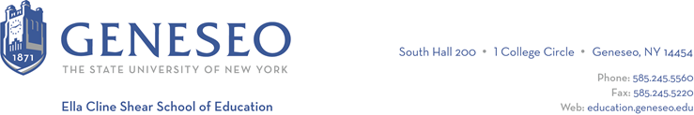

Hello,

Below is the weekly newsletter from the Coordinator of Advisement, Certification, and Communication. You’ll find upcoming School of Education events, along with professional development and employment opportunities shared with the SOE Dean’s Office (we don’t vet any of these opportunities, we just post what’s shared with us). If you have any questions or would like to get in touch with the people or organizations offering opportunities, please don’t hesitate to ask. I’m happy to forward any information I have.

Reminders:
If you are waiting for Geneseo’s Recommendation for teacher certification, an email from Chelsea O’Brien went out on Friday, June 7th. Please review that email prior to contacting the School of Education seeking information about certification or recommendations.

Faculty Activities:
Jennifer Sam and Dr. Julie Troman are presenting a two-part professional development session for NYS Master Teachers on Saturday, June 15. The session, Mentor Teacher Training Concepts, is meant to provide professional development for new and veteran cooperating teachers. Here is the blurb of their session:

"By the end of this workshop, School-Based Teacher Educators will be equipped with a comprehensive toolkit for mentoring teacher candidates with a keen understanding of the context of the current generation of pre-service educators as adult learners. We will explore innovative strategies and best practices for mentoring and the ability to leverage assessment tools for individualized, high-quality feedback for growth and learning."

Jennifer Sam and Dr. Julie Troman also attended the annual SUNY Clinical Practice Professional Consortium conference on June 6th.

Professional Development Opportunities:
Summer Institute Learning Conference - Old Westbury. Old Westbury is offering their 2nd Annual Summer Institute Learning Conference. More information and registration is available online.

Employment Opportunities:
Kharma Care is an inclusive childcare setting with about 80% of the children in care having special needs. Kharma Care is looking to hire some more staff for the summer. Resumes should be sent to dmartin@kharmacare.com.

Williamson Central School District is hiring an ENL/ESOL teacher for the district. Any interested parties are welcomed to apply.

Sagebrush Elementary School, part of the Cherry Creek School District in the Denver Metro aera, has two 5th grade teaching opportunities available. You can find more information online.

