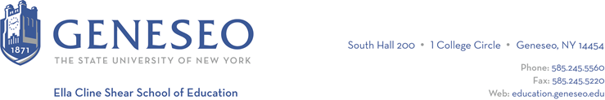

Hello,

Below is the weekly newsletter from the Coordinator of Advisement, Certification, and Communication. You’ll find upcoming School of Education events, along with professional development and employment opportunities shared with the SOE Dean’s Office (we don’t vet any of these opportunities, we just post what’s shared with us). If you have any questions or would like to get in touch with the people or organizations offering opportunities, please don’t hesitate to ask. I’m happy to forward any information I have. The newsletter will be bi-weekly over the summer.

Reminders:
The SOE Graduation Celebration will be held on Friday, May 17th at 3:30pm in Wadsworth Auditorium. No tickets required, bring your whole family and friends! We’ll be announcing scholarship winners and celebrating LIVES graduates, too! Remember to wear your cap and gown.

Geneseo’s commencement ceremony will be Saturday, May 18th and the School of Education ceremony will be 2pm-4pm. Tickets are required for this event, so graduates be sure to follow all of the instructions you’ve received by email. The SOE department gathering will take place in the MacVittie College Ballroom on the left side.

Employment Opportunities:
The Project Fibonacci Foundation Inc., a 501c3 registered nonprofit will be holding its sixth annual STEAM Leadership Conference in Rome, NY this summer August 4-10.
This is a week-long program where students in grades nine through 12 stay for one week while working on projects in science, technology, engineering, arts and mathematics. Students work in teams during the week developing a final presentation. This year's theme is Artificial Intelligence, The Smart Machine And The Human Factor. Students attend speaking series, workshops, field trips and attend social events all week long. We will be using MVCC Rome Campus and stay at the Hampton Inn. Facilitators (adult lead for a team to guide them through the process and help with any educational needs, and general student management) can be provided with overnight accommodations for the week as well as meals.

New World High School, a high performing New York City public school, located in the northeastern part of the Bronx, is excited to announce job openings for dedicated Science teachers. We are specifically looking for one Earth Science teacher and two Biology teachers to join our dynamic team. NYC Public Schools is the nation’s largest public school system, serving 900,000 students from every background and corner of the globe. To discover more about the exciting opportunities awaiting you at New World High School, we invite you to explore our website at www.newworldhs.org. All Inquiries should be directed to: mgashi@schools.nyc.gov.

