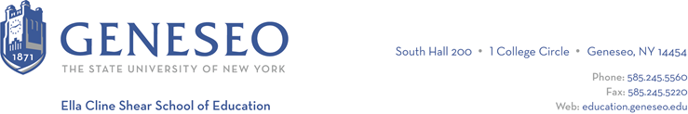

Hello,

Below is the weekly newsletter from the Coordinator of Advisement, Certification, and Communication. You’ll find upcoming School of Education events, along with professional development and employment opportunities shared with the SOE Dean’s Office (we don’t vet any of these opportunities, we just post what’s shared with us). If you have any questions or would like to get in touch with the people or organizations offering opportunities, please don’t hesitate to ask. I’m happy to forward any information I have.

Geneseo Event Highlights for Educators:
From Local to Global: Contemporary Challenges and Innovative Solutions on April 19th in Doty Hall, ending in the Multicultural Center. There will be workshops, student panels, community panels, a keynote address from Dr. Sinfree Makoni from Penn State's Applied Linguistics and African Studies departments, multiple cultural performances from the Rochester area and a full day of meals and snacks planned out. Register online.

Professional Development Opportunities:
The SUNY Undergraduate Research Conference (SURC) 2024 for the western region will be held on Monday, April 15 at the University at Buffalo. Abstract submissions are now open and the abstract submission deadline is March 31, 2024. Since the registration deadline is also the same day I encourage students to submit their abstracts as soon as possible. Guidelines and proposals are available online, students should be sure to submit abstracts to the conference at the University at Buffalo. Geneseo will cover the registration costs of any students (and their faculty sponsors) whose presentations are accepted for the conference. Once students have submitted their abstract, they should complete this Geneseo SURC 2024 Attendees form.

Teacher Recruitment Day - Register Today!

Teacher Recruitment Day (TRD)
Tuesday, April 16, 2024
8:00 a.m. - 4:00 p.m.
Niagara Falls Convention Center, Niagara Falls, NY
In-Person Interview Job Fair
Registration is open through April 2

See the Registration Handout and the TRD website for more information. Will you be certified to teach by September 1, 2024? Don't miss this opportunity to connect with over 115 schools from WNY and across the US (including many from the Rochester area.) TRD is a one-day pre-select interview program and job fair event for candidates in K-12 careers to network and interview with local, national, and international school districts. Participating schools will review resumes and may invite you to interview with them. Check the list of participating employers online.

Employment Opportunities:
City of Rochester Summer Opportunities include Summer Leap Teacher/Seasonal, Summer Aquatic Positions, and Summer Recreation Positions

Rochester Prep Elementary School is seeking an Elementary School Principal for the 24-25 school year.

