Accommodate Student User Instructions: Supplemental Requests
SUNY Geneseo
Office of Accessibility Services (OAS)

The OAS has implemented a new accommodation management platform called Accommodate. Your Accommodate portal will house important information about your accommodations. Please follow the step-by-step instructions below to request academic accommodations and access and navigate your Accommodate portal.

To submit a request for supplemental academic accommodations, login to Accommodate with this link: https://geneseo-accommodate.symplicity.com/students/
After you log-in you will arrive in the “Home” section.
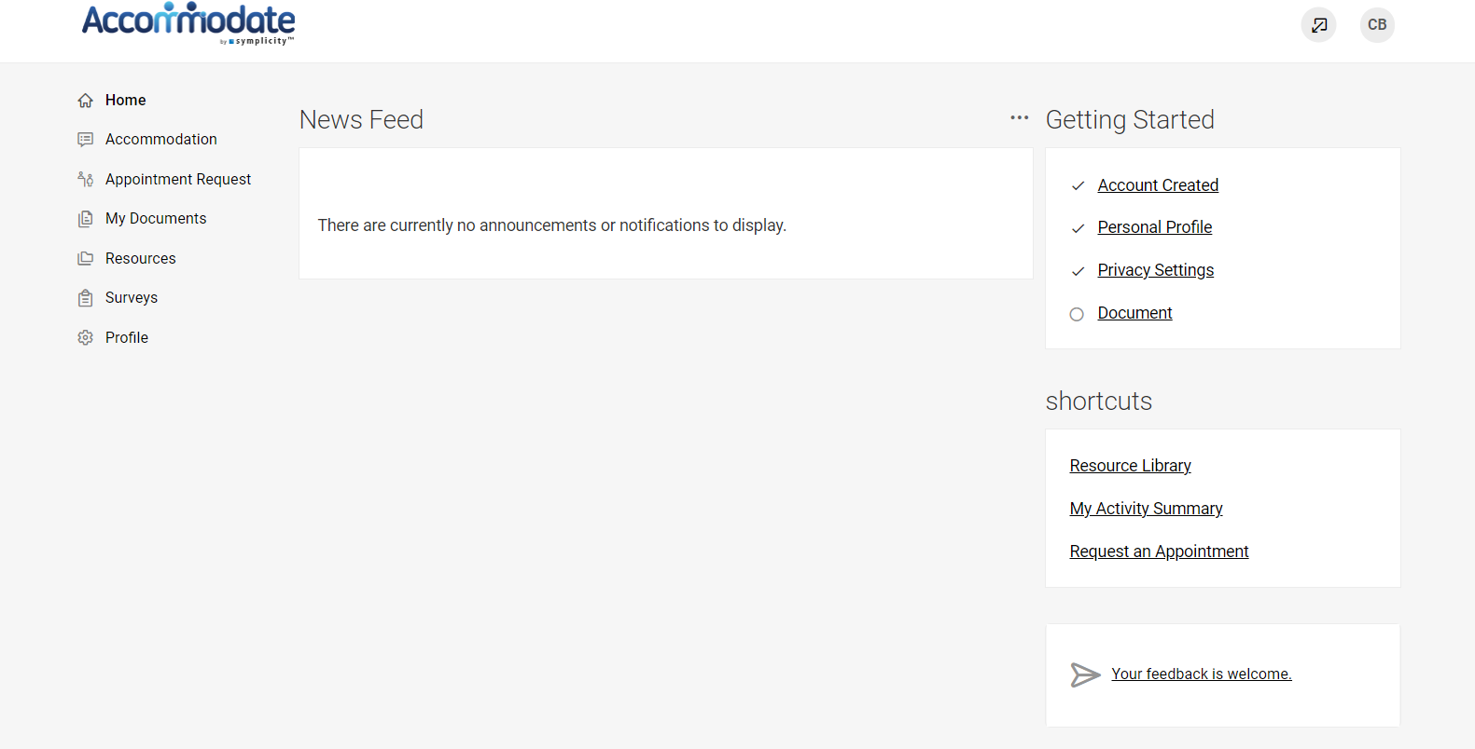
Then Select “Accommodation” > “Supplemental Request” > “Add New”. Once you’ve completed the form, click ‘submit.’

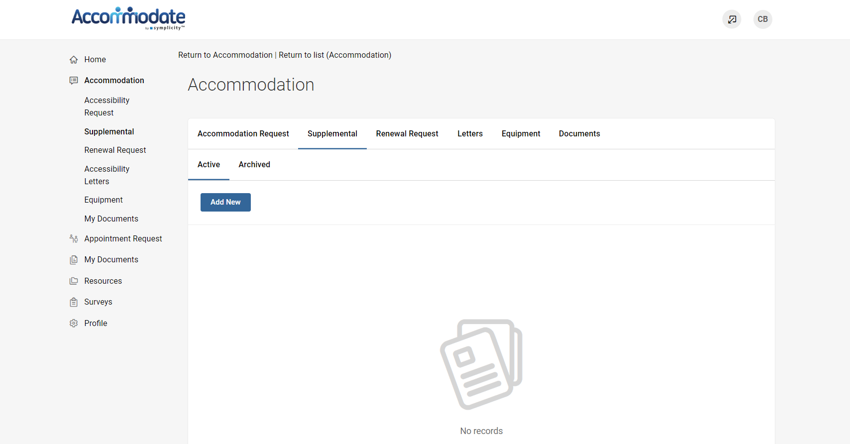

To upload updated documentation, you may do so via the Supplemental request, or select “My Documents” > “Add New”. You may also send documentation to the OAS via email (access@geneseo.edu), fax (585-245-5091), or in-person (Erwin Hall 22).
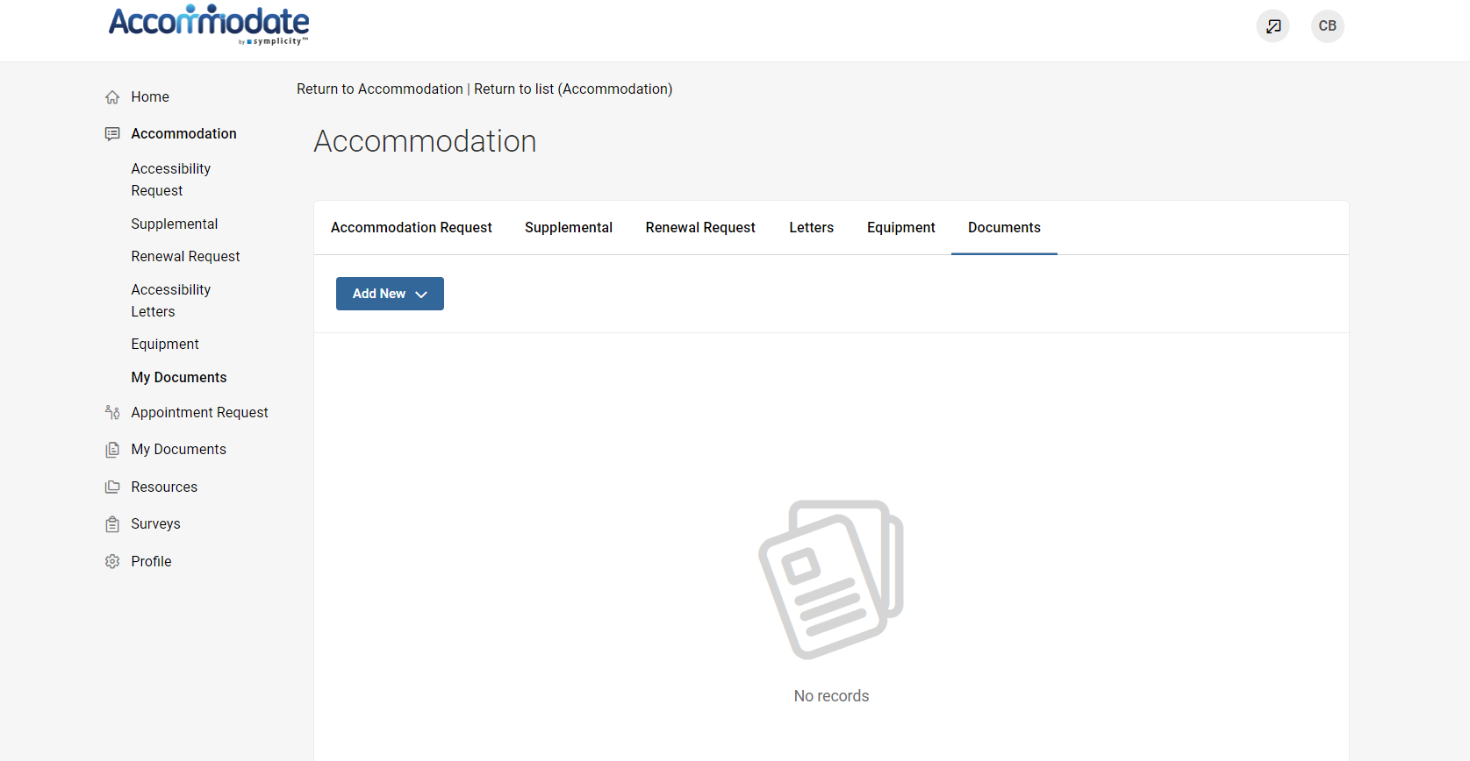

You will receive an email request to request an appointment. To request an appointment with an OAS staff member, select “Appointment Request” > “Request New Appointment”.
The OAS can meet with students Monday – Friday, 9:00am – 3:00pm.

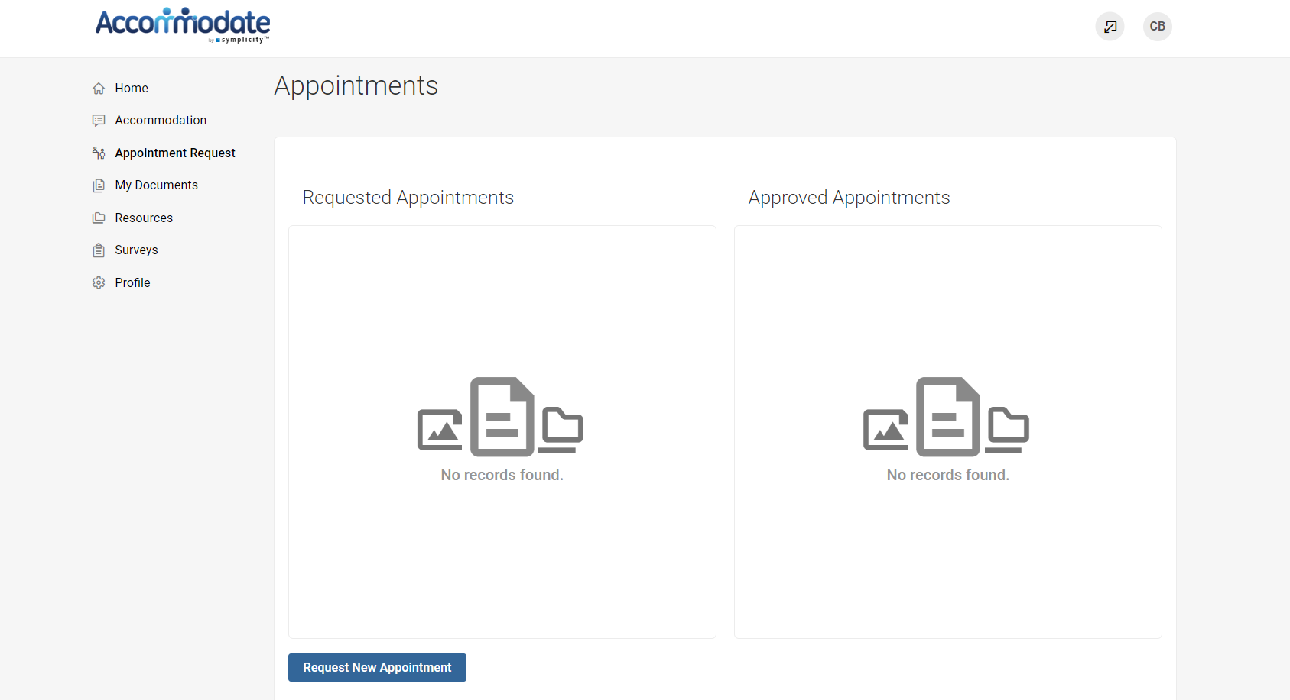

To view your original accessibility request, select “Accommodation” > “Accessibility Request”
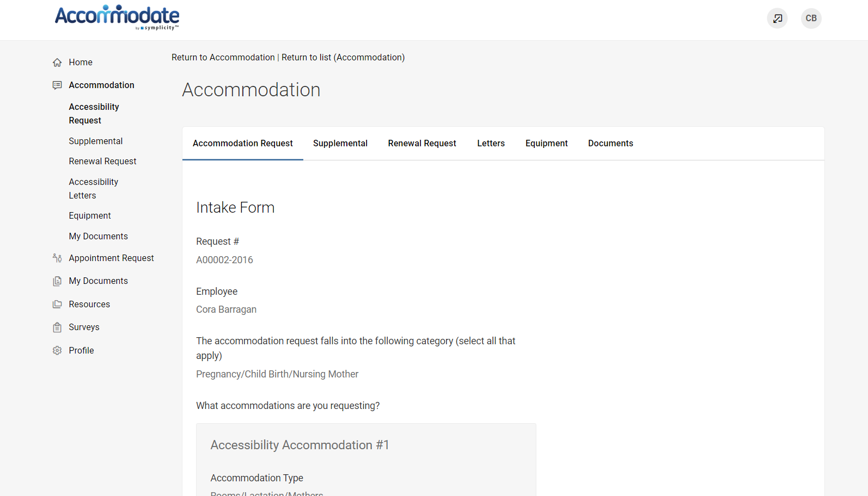

If you are approved for updated academic accommodations, you will be sent your letter via email. To view your accommodation letters, select “Accommodation” > “Letters’’
Once the letter is open, you have the option to print or generate a PDF of the accommodation letter. To return to the full list, select “Return to List (Accommodation Letter)”
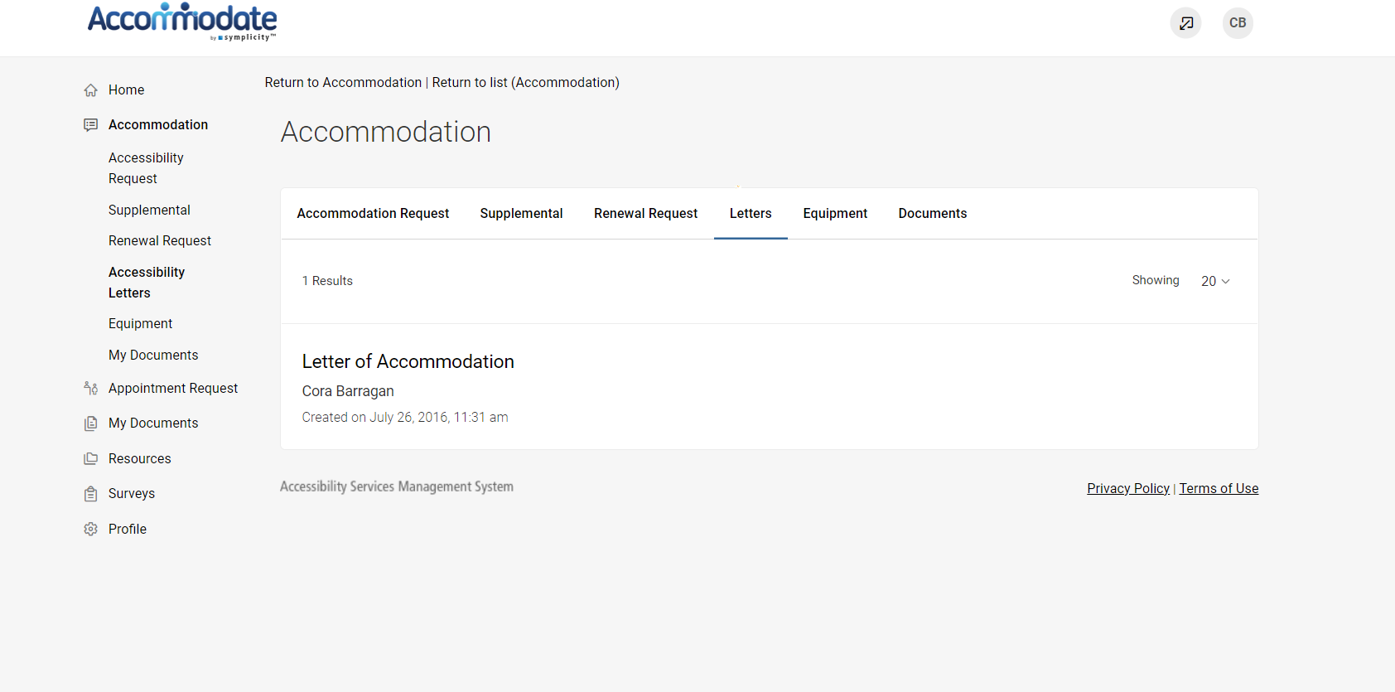

By selecting “Profile” on the homepage you can view and edit your account details

