Accommodate Student User Instructions: PAR Submission for New Students
SUNY Geneseo
Office of Accessibility Services (OAS)

The OAS has implemented a new accommodation management platform called Accommodate. Your Accommodate portal will house important information about your accommodations. Please follow the step-by-step instructions below to request academic accommodations and access and navigate your Accommodate portal.

To submit an initial academic accommodation request, use this URL to submit a Public Accommodation Request: https://geneseo-accommodate.symplicity.com/public_accommodation/
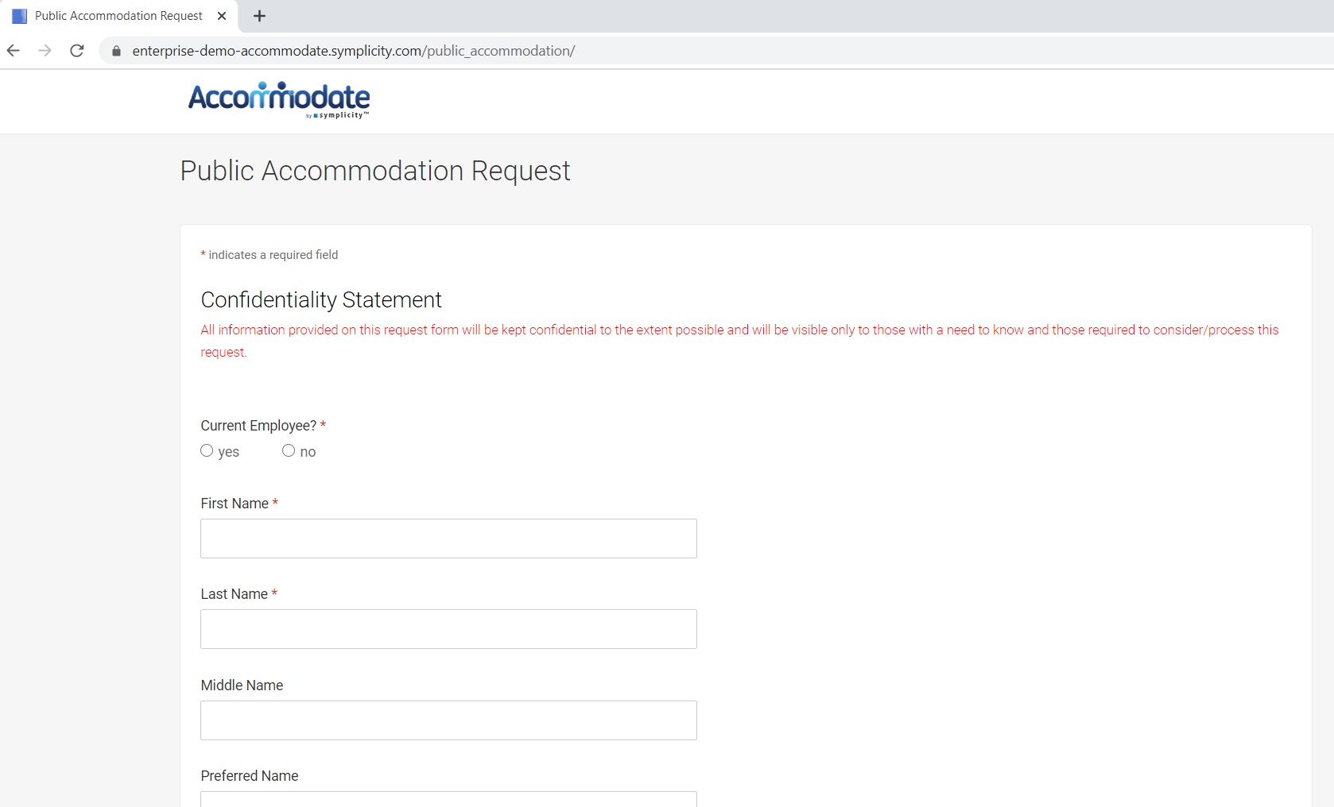

To upload documentation, you may do so via the PAR, or select “My Documents” > “Add New”. You may also send documentation to the OAS via email (access@geneseo.edu), fax (585-245-5091), or in-person (Erwin Hall 22).
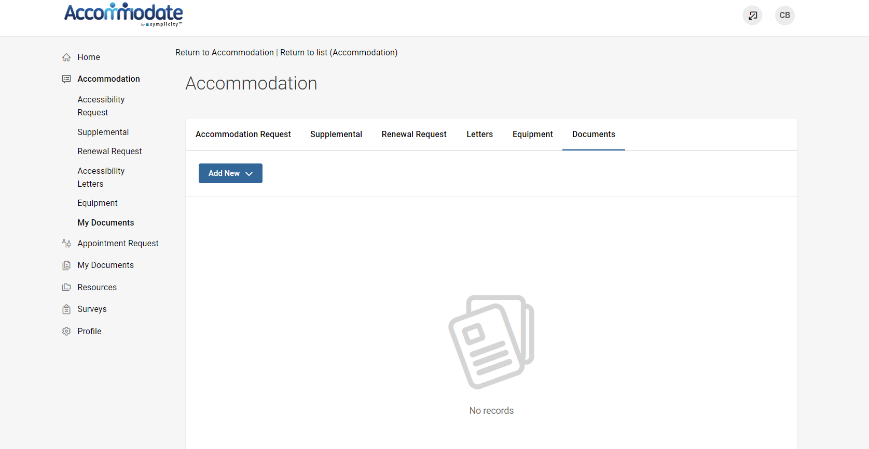

Once you submit your PAR, you may log-in to Accommodate here: https://geneseo-accommodate.symplicity.com/students/ and select “Student”

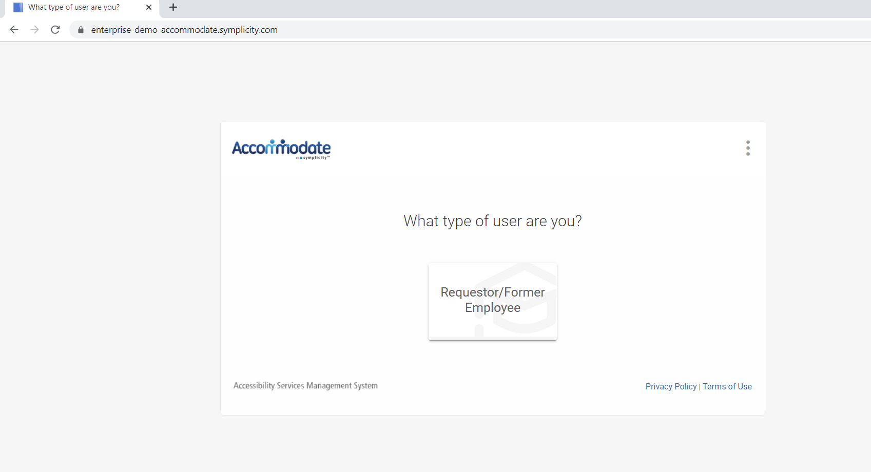

After you log-in you will arrive in the “Home” section.
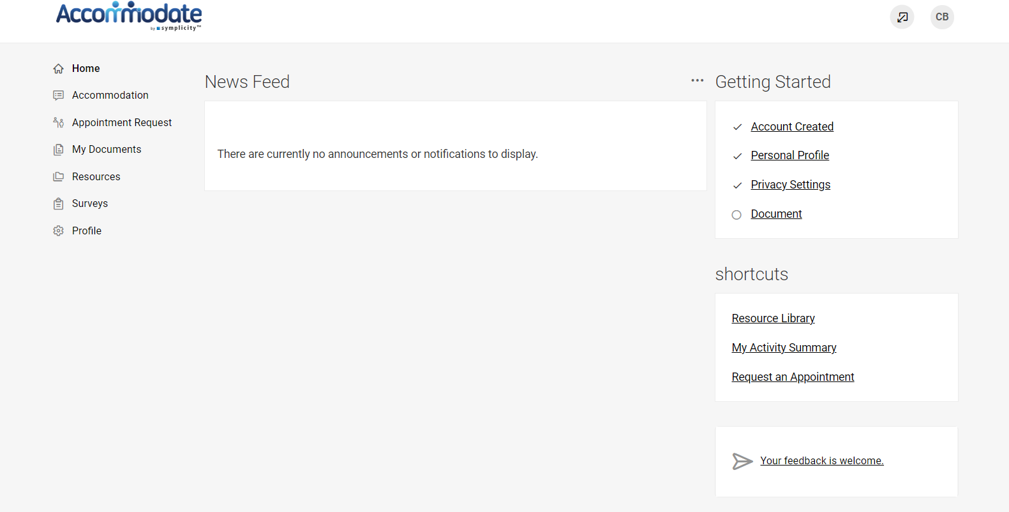

To view your original accessibility request, select “Accommodation” > “Accessibility Request”
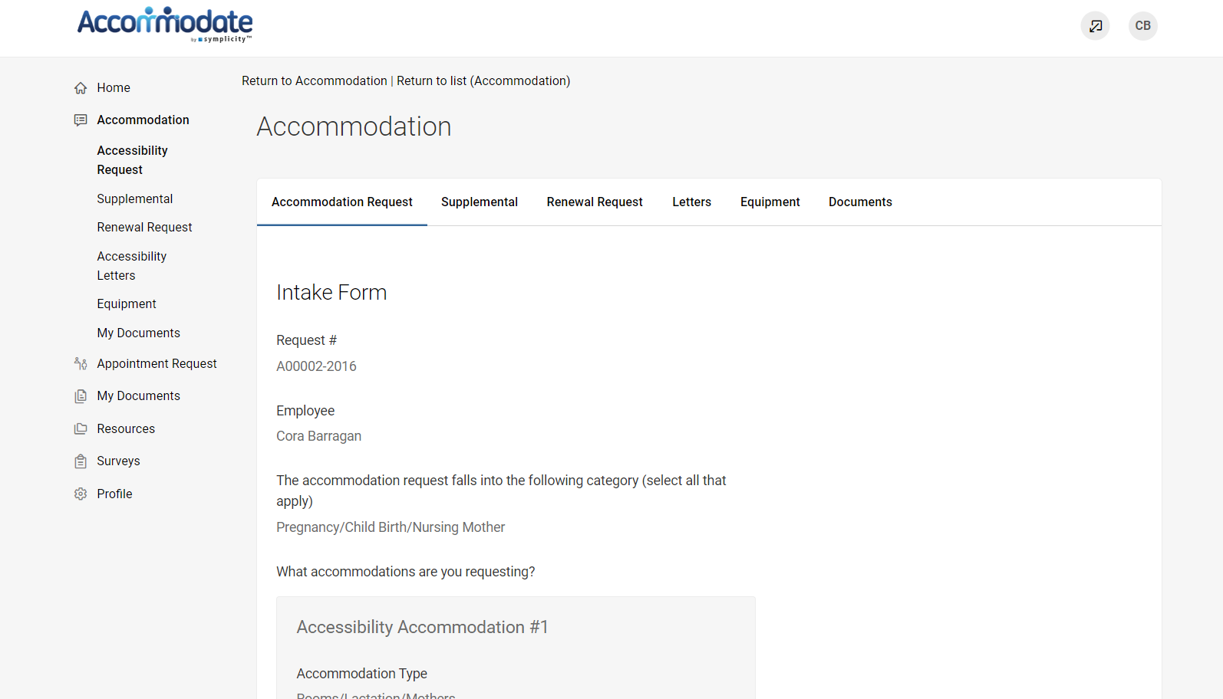

After you submit a PAR request, you will receive an email request to request an appointment. To request an appointment with an OAS staff member, select “Appointment Request” > “Request New Appointment”.
The OAS can meet with students Monday – Friday, 9:00am – 3:00pm.

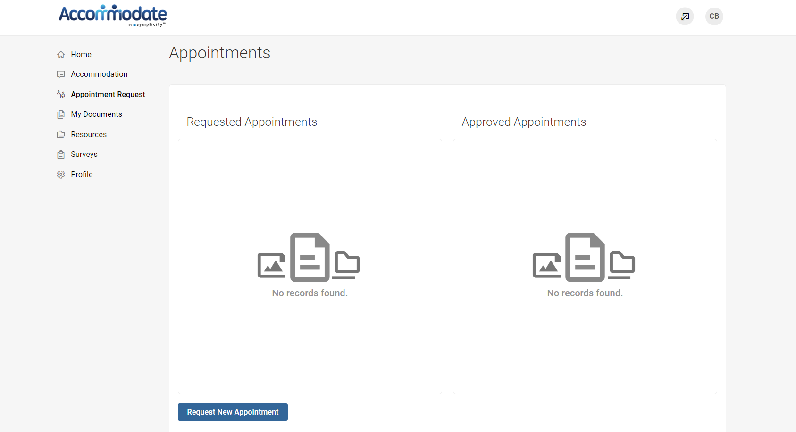

If you are approved for academic accommodations, you will be sent your letter via email. To view your accommodation letters, select “Accommodation” > “Letters’’
Once the letter is open, you have the option to print or generate a PDF of the accommodation letter. To return to the full list, select “Return to List (Accommodation Letter)”

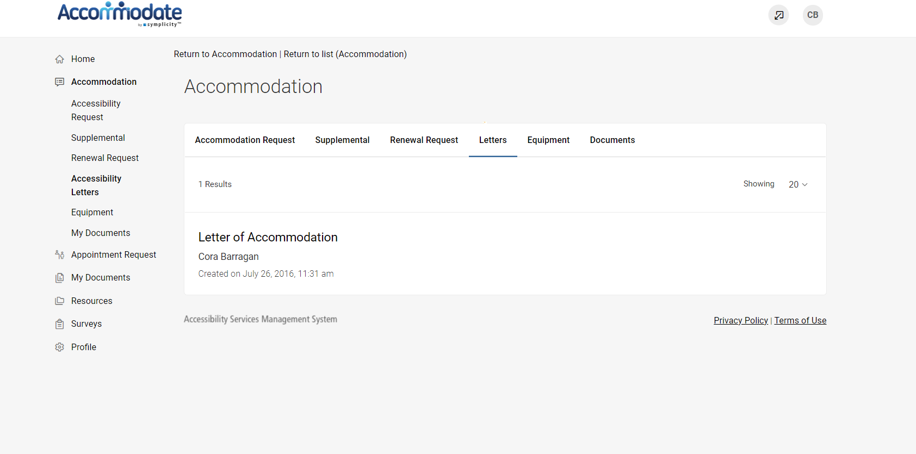

By selecting “Profile” on the homepage you can view and edit your account details

